Carla Cesare

Columbus College of Art & Design

**Reich, Lilly (1885 -1947)**

Lilly Reich was a German born designer who created interiors, displays and exhibitions in the early to mid-20th century. She was active in the DEUTSCHER WERKBUND and the BAUHAUS, and was the first woman architect to be given a retrospective at the Museum of Modern Art in New York in 1996. Reich’s career as a female designer has been argued by critic Beatriz Colomina as an example of the collaborative nature of architecture in which women have often played an unspoken role.

Reich was one of the few women designers to have a position of leadership in the early 20th century, yet has had little academic renown. As is common for women designers of the time they are often known in relation to their work with more prominent male architects or designers; for Reich, LUDWIG MIES VAN DER ROHE was both a personal and professional partner. Reich, from a wealthy manufacturing family, studied at the *Wiener Werkstaette* (1908) then in 1910 at the *Hohere Fachschule fur Dekorationkunst* in Berlin. Typical for women of the period she had a focus on textiles, needlework and fashion along with set design and display.

Two major events occurred for Reich in the immediate years immediately following the end of her education; her first professional interior design job was the 32 rooms of the *Jugendzentrum* in Berlin; second was when she joined the *Deutscher Werkbund*. The purpose and activities of the *Werkbund*; sponsoring exhibitions, educational programmes and alliance with industry, allowed Reich the opportunity for not only jobs, but to work with its organizational and promotional activities. So much so that she became the first female board member.

While keeping active in the *Werkbund* Reich also opened up her own boutique of her clothing designs. In the mid-1920s two events occurred which furthered her career; first she had the opportunity to design a fashion exhibit for the International Frankfurt Fair which offered her the opportunity to work with fashion through important department stores in Germany which later lead to residential interior work. The second major event was when Reich met Mies van der Rohe, which led to professional collaborations starting with the *Werkbund* exhibition *Die Wohnung* in 1927 in Stuttgart. Also in 1927 was her work , with Mies van der Rohe again on the women’s Velvet and Silk Café; (image) her use of sensual fabrics to create divides by suspending them over rods were to become not only her trademark, but marked the point where her influence on Mies van der Rohe became evident. In 1928 she worked on the interiors of Mies’ controversial Tugenhadt residence in Brno, Czechoslovakia. When Mies received the commission for the Barcelona Pavilion (the German Pavilion at the International Exhibition) in 1929, which spawned the famed Barcelona chair, he listed Reich as his co-collaborator.

Importantly, when Mies van der Rohe became director of the influential Bauhaus school in 1930 he hired Reich as the head of the weaving workshops (1932-33). This was a controversial move as Reich had no weaving experience and students supported her assistant Otti Berger for the role. When Mies left Germany for the United States in 1938, Reich opted to stay in Germany. This choice may have stunted her career as those who left went on to greater renown. It has also led to questioning her role in support of the Nazi government, as she continued to take government commissions including the highly politicized 1937 World’s Fair in Paris. Her subtle and unique use of space and textiles influenced one of the most well-known architects, impacting modern design today. Reich passed away in 1945 after a long illness, having achieved a rare level of professional success for a woman designer, in an often highly politicized environment.

**List of Works**

1912 Sample flat for a working-class family in the Berlin Gewerkschaftshaus (Trade Union House), Berlin

1927 Wohnraum in Spiegelglas (Living Room in Mirror Glass), Werkbund Exhibition,

1927 Velvet and Silk Café, Berlin

1927 MR Lounge Chair

1929 Barcelona Chair

1930 Brno Tubular Chair for the interior of the Tudenghat House ,Czech Republic

1931 Deutsche Bau-Ausstellung, architectural trade fair, Berlin

**Further Reading**

Lange, C. (2006) *Ludwig Mies van der Rohe und Lilly Reich*. Ostfildern: Hatje Cantz.

Bauhaus-Archiv Berlin (Hg.) (2003) *Bauhaus-Möbel*. Eine Legende wird besichtigt, Berlin.

Günther, S. (1988) *Lilly Reich, 1885-1947*. Stuttgart.

Nerdinger, W. (Hg.) (1993) Bauhaus-Moderne im Nationalsozialismus, München.

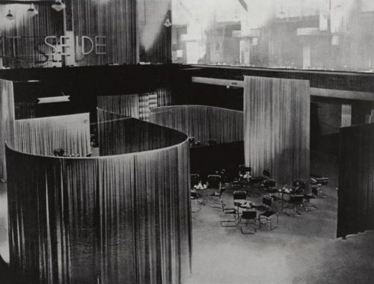

Velvet and Silk Café, Berlin (1927)

<http://mikasavela.tumblr.com/post/6313858486/the-velvet-and-silk-cafe>

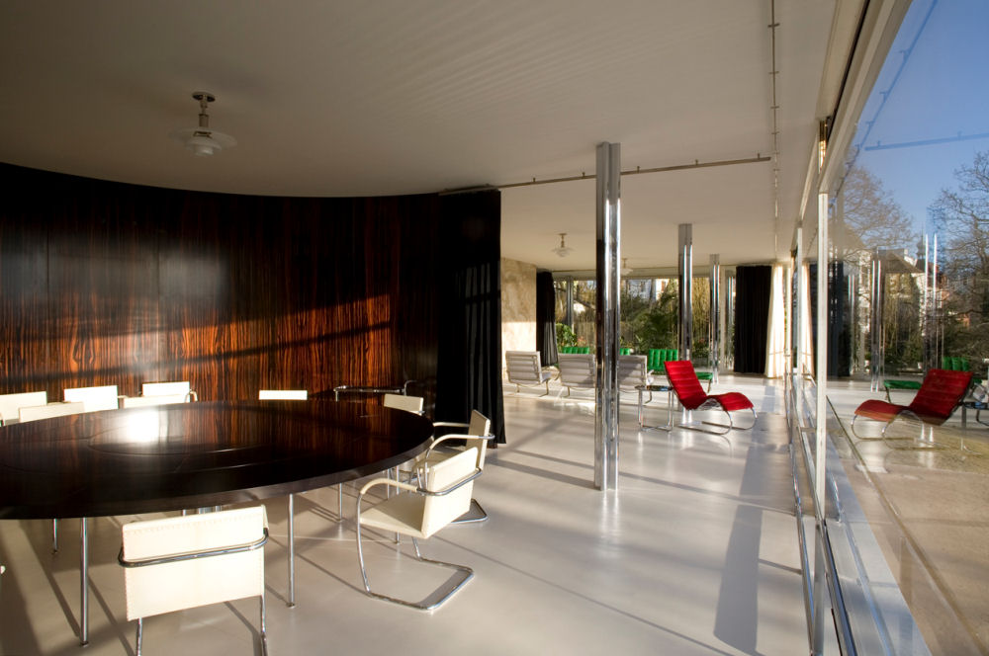

Tugenhadt residence, Brno, Czech Republic (1930)

<http://www.private-prague-guide.com/article/the-villa-tugendhat-an-architectural-gem-in-brno/>

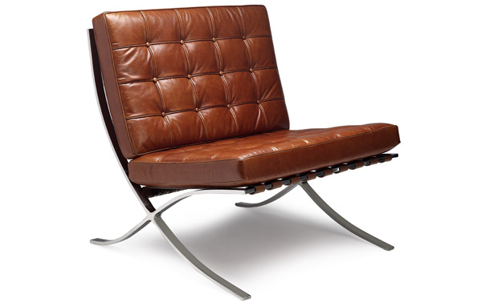

Barcelona Chair (1929)

<http://iconicinteriors.com/images/uploads/products/buy-barcelona-chair-vintage.jpg>